This document will detail the steps required to calculate the power factor for GSD customers having AMI meter being billed a power factor.
For GSD customers being billed with power factor whose meter have been replaced with an AMI meter, there will no longer be a power factor register. There will be a new index register for KVARH. The power factor will be calculated using the KWH and KVARH index reads.

Get the total KVARH and KWH consumption
  - Via Installation Facts

Get the KWH and KVARH consumption from the installation facts. Note that the consumption is only available from the installation facts once the billing period has been billed.

    - Display the installation

From the SAP menu, execute transaction ES32 to display the installation

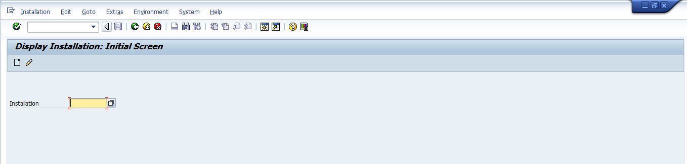
Populate the Installation number and click on Enter.

    - Display the Installation Facts

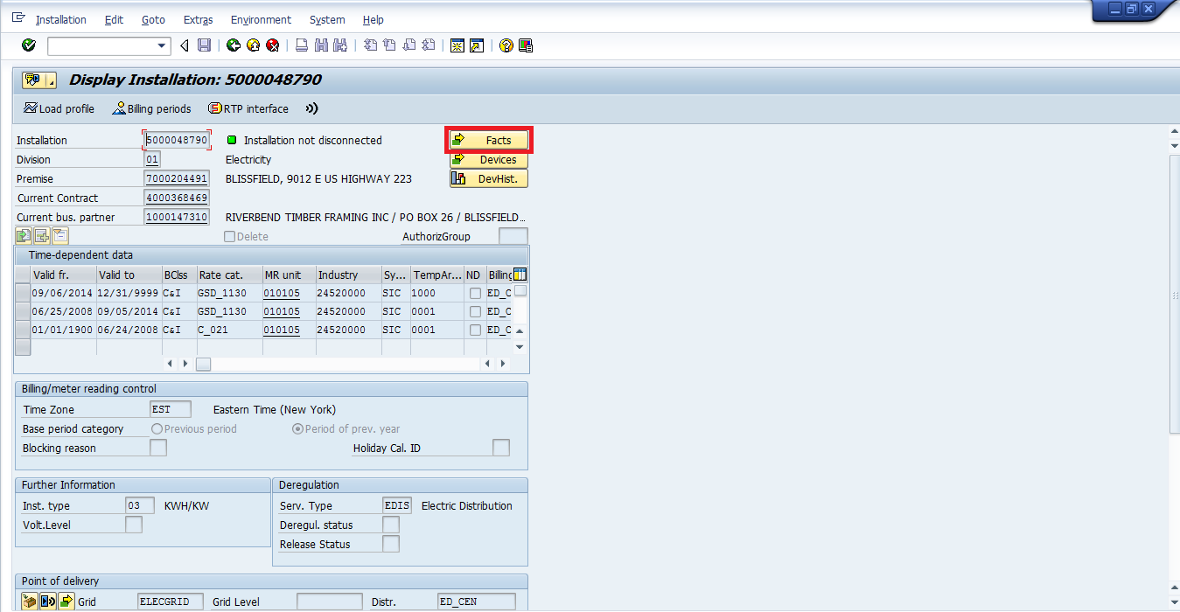
Click on Facts button to display the installation facts.

    - Display the total KWH and KVARH consumption

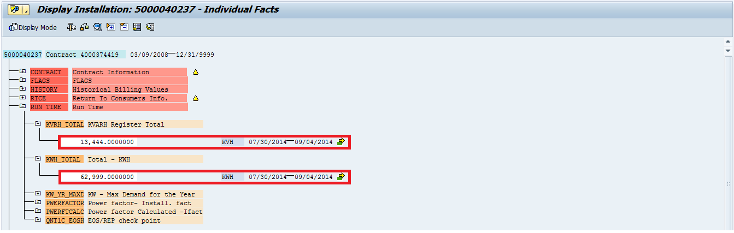

Expand RUN TIME node.
The KWH consumption is stored in operand KWH_TOTAL.
The KVARH consumption is stored in operand KVRH_TOTAL.

Note: If you need to view previous billing periods, double-click on the operand name (ie. KWH_TOTAL or KVRH_TOTAL)

  - Via Meter Reading Data

As an alternative, you can also get the KWH and KVARH consumption from the register reads.

    - Display the meter reading data

From the SAP menu, execute transaction ES32 to display the installation

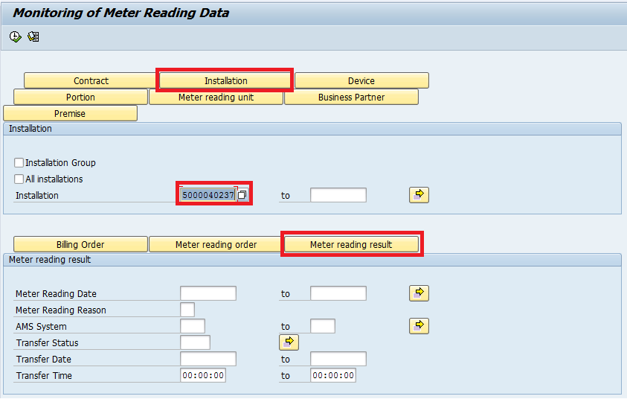

Click on the Installation button and enter the installation number.
Click on the Meter reading result button and Execute.
This will take you to the Meter Reading Results screen.
    - Meter reading results: Overview

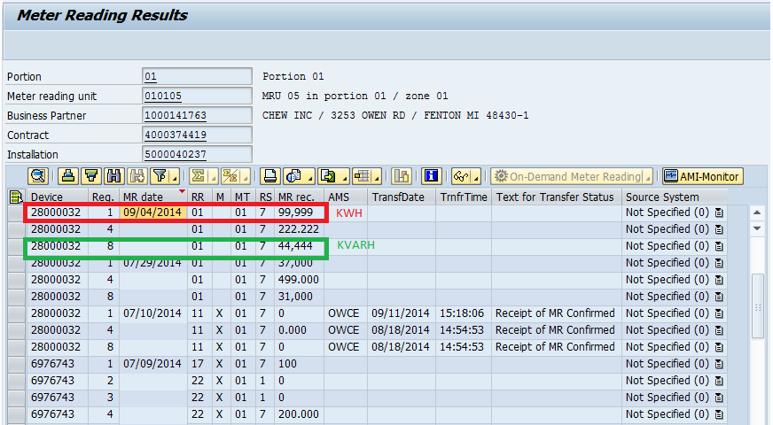

From the Meter Reading Results screen, determine the date you want to use.
The KWH register is register 1.
The KVARH register is register 8.
To view the meter reading results data, double-click on either the MR date or the MR rec.

    - Meter reading results: Details

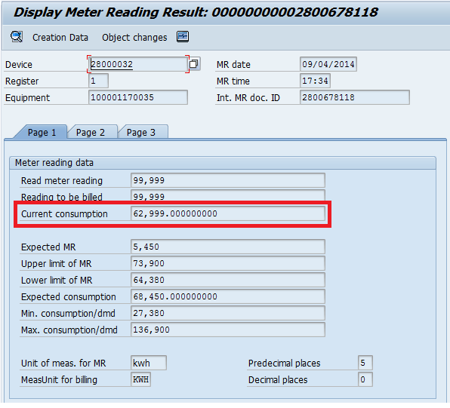
Consumption can be found in Page 1 in field Current consumption

Calculate the ratio of reactive (KVARH) to active (KWH) energy
Ratio = total KVARH consumption / total KWH consumption

For example: KWH consumption = 62,999; KVARH consumption = 13,444
Ratio = 13,444/62,999 = 0.21340021

Calculate the interim factor
Interim factor = Ratio * 100
Interim factor = 0.21340021 * 100 = 21.340021

Get the associated PF from table EPOWERF
Using the Power factor table, get the associated power factor.

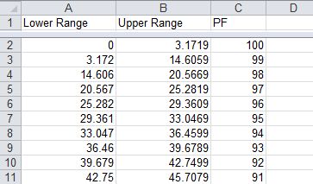
Find the row where the interim factor from step 3 is between the values in Lower Range and Upper Range.
For interim factor 21.340021, the associated PF is 97.

Calculate the billing power factor
PF = Associated PF / 100
PF = 97/100 = 0.97
Note: This is the value stored in installation fact PWRFACTOR.

